**Generating Association Rules**

# Association Rules Mining General Concepts

This is an example of **Unsupervised** Data Mining-- You are not trying to predict a variable.

All previous classification algorithms are considered Supervised techniques.

Given a set of transactions, find rules that will predict the occurrence of an item based on the occurrences of other items in the transaction.

Nominal attributes are required.

**Affinity Analysis** is the process of determining which things go together. This is also called **market basket analysis.** For example, we may have the following products: Milk, Cheese, Bread, Eggs

Possible **associations** include:

1. if customers purchase milk they also purchase bread **{milk} → {bread}**
2. if customers purchase bread they also purchase milk **{bread}→ {milk}**
3. if customers purchase milk and eggs they also purchase cheese and bread **{milk, eggs} → { cheese, bread}**
4. if customers purchase milk, cheese, and eggs they also purchase bread **{milk, cheese, eggs} → {bread}**

Based on a set of transactions of customers

Note that #1 and #2 are not the same as is demonstrated in the confidence rating of each rule described below.

**Implication means co-occurrence, not causality!**

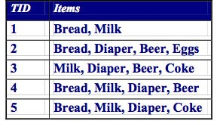

**Definition: Frequent Itemset**

**Itemset**

**:**

A collection of 1 or more items

{

bread, milk, diaper

}

**Support Count:**

Support count, σ, is the frequency count of occurences of the itemset

σ({bread,milk,diaper}) = 2

**Support**

(similar to the idea of coverage with decision rules)

Support is the percentage of instances in the database that contain all items listed in an itemset

For the bread AND milk cases #1 and #2 we might have σ(bread and milk) = 5000 out of 50000 instances for s=10% support or in the case of the tiny 5 items dataset, we would have σ=3 out of 5 instances for s=60%.

## Association Rule

An association rule is an implication expression of the form **X → Y**, where X and Y are itemsets Example: {Milk, Diaper} → {Beer}

## Confidence

(similar to the idea of accuracy with decision rules)

Each rule has an associated confidence: the conditional probability of the association.

E.g., the probability that purchasing a set of items they then purchase another set of items, so if there were 10000 recorded transactions purchasing milk, and of those 5000 purchase bread, we have 50% confidence for rule #1.

For rule #2, we might have 15000 purchasing bread, of which 5000 purchased milk, then it is 33% confidence.

In the 4 itemset example

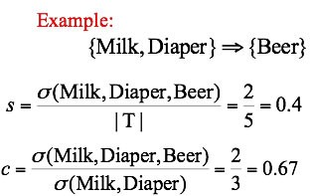

# Item Sets

Item sets are attribute-value combinations that meet a specified coverage requirement (minimum support). Item sets that do not make the cut are discarded.

We can also talk about minimum confidence.

# Association Rules Mining Approach

Given a set of transactions, T, the goal of association rule mining is to find all rules having

**support ≥ minSup threshold confidence ≥ minConf threshold**

Brute-force approach:

List all possible association rules

Compute the support and confidence for each rule

Prune rules that fail the minSup and minConf thresholds

Computationally prohibitive! (exponential O(3n))

Below is a graph showing the total number of rules to consider for d unique items.

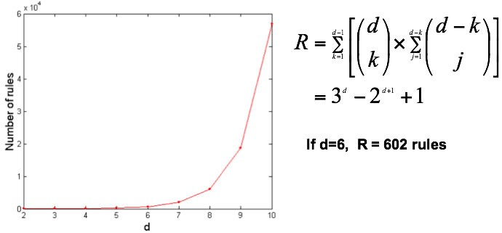

# Example of Rules

{Milk,Diaper}→ {Beer} (s=0.4, c=0.67)

{Milk,Beer} →{Diaper} (s=0.4, c=1.0)

{Diaper,Beer}→ {Milk} (s=0.4, c=0.67)

{Beer} → {Milk,Diaper} (s=0.4, c=0.67)

{Diaper} → {Milk,Beer} (s=0.4, c=0.5) {Milk} → {Diaper,Beer} (s=0.4, c=0.5)

Observations:

All the above rules are binary partitions of the same itemset: {Milk, Diaper, Beer}

Rules originating from the same itemset have identical support but can have different confidence

Thus, we may decouple the support and confidence requirements

# Mining the Association Rules

Two-step approach:

1. Frequent Itemset Generation

Generate all itemsets whose **support >minsup**

1. Rule Generation

Generate high confidence rules from each frequent itemset, where each rule is a binary partitioning of a frequent itemset

Frequent itemset generation is still computationally expensive.

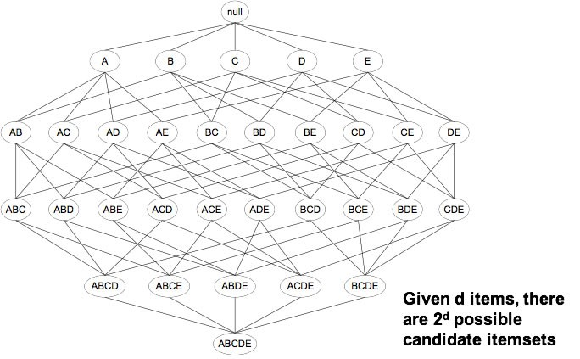

# Frequent Itemset Generation

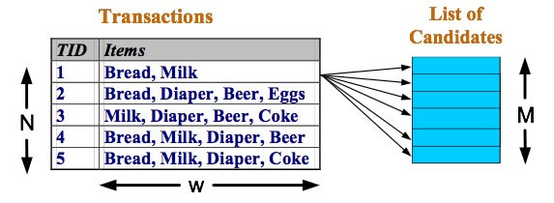Brute-force approach:

Each itemset in the lattice is a candidate frequent itemset Count the support of each candidate by scanning the database Match each transaction against every candidate

Complexity is exponential ~ O(NMw), which is expensive since M = 2d !!!

## Strategies

Reduce the number of candidates (M)Complete search: M=2d

Use pruning techniques to reduce M (use Apriori principle, below)

Reduce the number of transactions (N)

Reduce size of N as the size of itemset increases

Used by DHP and vertical-based mining algorithms

Reduce the number of comparisons (NM)

Use efficient data structures to store the candidates or transactions No need to match every candidate against every transaction

**Apriori principle:**

If an itemset is frequent, then all of its subsets must also be frequent

Apriori principle holds due to the following property of the support measure:



, X and Y are itemsets

Support of an itemset never exceeds the support of its subsets

This is known as the anti-monotone property of support

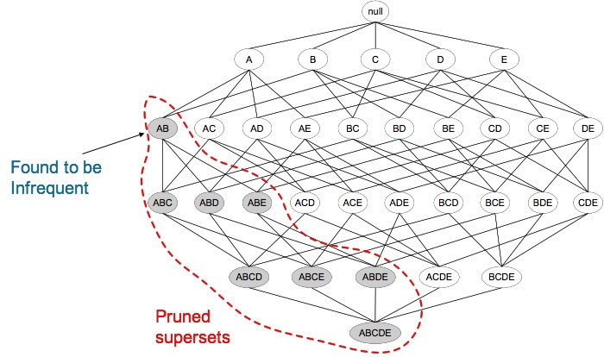

Example step through

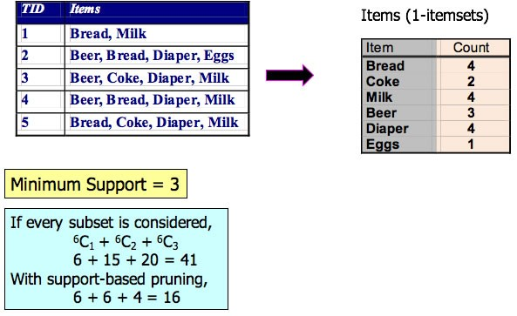

# The formal Apriori algorithm

Fk: frequent k-itemsets

Lk: candidate k-itemsets

Algorithm

Let k=1

Generate F1 = {frequent 1-itemsets} Repeat until Fk is empty:

Candidate Generation: Generate Lk+1 from Fk

Candidate Pruning: Prune candidate itemsets in Lk+1 containing subsets of length k that are infrequent Support Counting: Count the support of each candidate in Lk+1 by scanning the DB

Candidate Elimination: Eliminate candidates in Lk+1 that are infrequent, leaving only those that are frequent => Fk+1

Informally, the algorithm is

Finding one-item sets easy

Use one-item sets to generate two-item sets, two-item sets to generate three-item sets, …

Keep only those item sets that meet the support threshold at each level to prune those at higher levels.

Then partition the retained item sets into rules and keep only those that meet the confidence threshold.

# Example 2: credit card promotion database

This example considers a dataset of nominal values, although binary, both of which can be considered interesting. Unlike marketbasket where only purchases are interesting.

Single itemsets now can be twice as large than above.

Single item sets at a 40% coverage threshold:

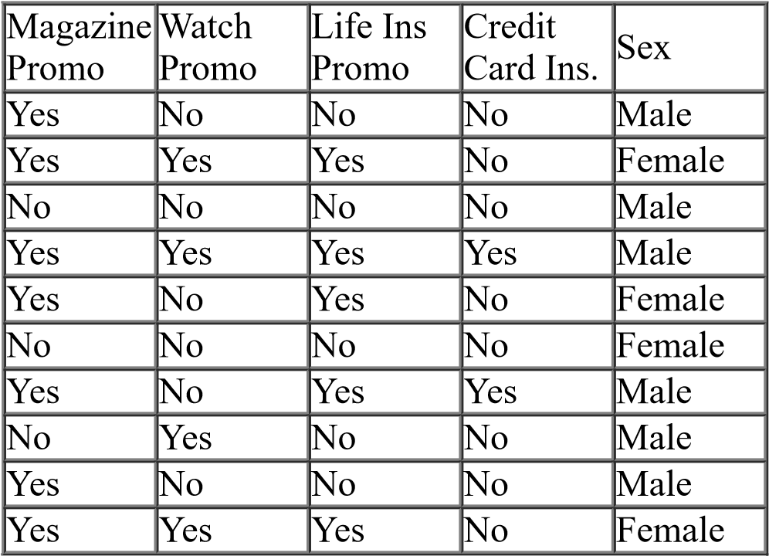

**single item sets**

**Number of**

**items**

A. Magazine Promo=Yes

7

B. Watch Promo=Yes

4

C. Watch Promo=No

6

D. Life Ins Promo=Yes

5

E. Life Ins Promo=No

5

F. Credit Card Ins=No

8

G. Sex=Male

6

H. Sex=Female

4

# Pairing--Step 2

Now begin pairing up combinations with the same coverage threshold (again 40% here)

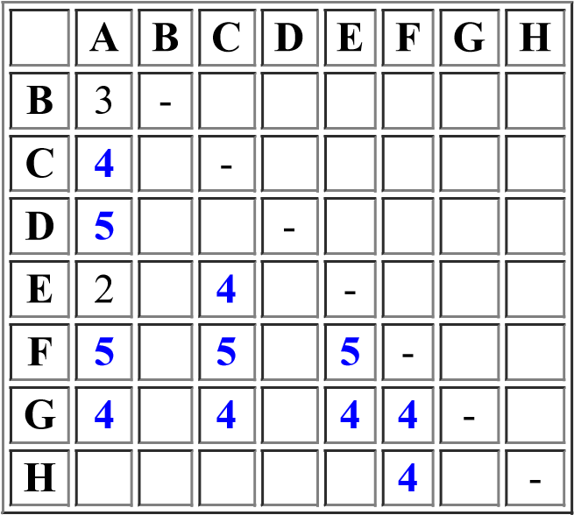

**single item sets**

**Number of items**

A. Magazine Promo=Yes

7

B. Watch Promo=Yes

4

C. Watch Promo=No

6

D. Life Ins Promo=Yes

5

E. Life Ins Promo=No

5

F. Credit Card Ins=No

8

G. Sex=Male

6

H .Sex=Female

4

**Resulting rules from two item sets. Consider rules in both directions:**

1. (A → D)

( MagazinePromo=Yes )→ ( LifeInsPromo=Yes ) at 5/7 confidence

1. (D → A)

( LifeInsPromo=Yes ) → (MagazinePromo=Yes ) at 5/5 confidence

1. twenty more rules from the 10 two-item-sets (A then C, C then A, A then F, F then A, etc.)

## Now apply minimum confidence threshold

If confidence threshold would be 80%, then the first rule ( A → D) is eliminated.

**Repeat process** for 3 item set rules, then 4 item set rules, etc., but keep the support and confidence thresholds the same.

# Candidate Generation: Fk-1 x Fk-1 Method

Merge two frequent (k-1)-itemsets if their first (k-2) items are identical

Example F3 = {ABC,ABD,ABE,ACD,BCD,BDE}

Lexicographically ordered!

Candidate four-item sets are:

Merge(**AB**C, **AB**D) = **AB**CD

Merge(**AB**C, **AB**E) = **AB**CE

Merge(**AB**D, **AB**E) = **AB**DE

Do not merge(**A**BD,**A**CD) because they share only prefix of length 1 instead of length 2 (A C D E) Not candidate because of no (C D E)

L4= {ABCD,ABCE,ABDE} is the set of candidate 4-itemsets generated from first method

Candidate pruning

Prune ABCE because ACE and BCE are infrequent

Prune ABDE because ADE is infrequent

After candidate pruning: F4 = {ABCD}

## Alternate Fk-1 x Fk-1 Method

Merge two frequent (k-1)-itemsets if the last (k-2) items of the first one is identical to the first (k-2) items of the second.

F3 = {ABC,ABD,ABE,ACD,BCD,BDE,CDE}

Merge(A**BC, BC**D) = A**BC**D

Merge(A**BD, BD**E) = A**BD**E

Merge(A**CD, CD**E) = A**CD**E

Merge(B**CD, CD**E) = B**CD**E

L4= {ABCD,ABDE,ACDE,BCDE} is the set of candidate 4-itemsets generated from second method pruning results in F4 = {ABCD} why are others eliminated?

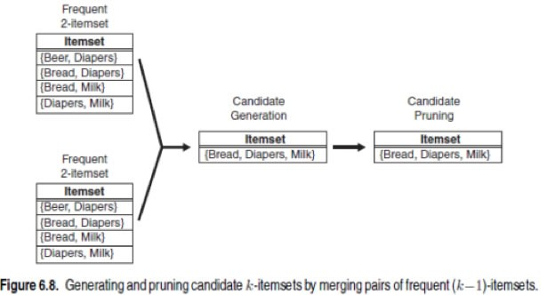

**Rule generation**

A three item set will be partitioned to generate 6 rules:

An item set (A B C) generates rules

(A & B) → C,

1. & C) → B,
2. & C) → A,
3. → (B & C),
4. → (A & C),
5. → (A & B)

Example 4 item set L = (A B C D), the partitioning result in the following rules

ABC → D, ABD→ C, ACD → B, BCD → A, A → BCD, B → ACD, C → ABD, D → ABC

AB → CD, AC → BD, AD→ BC, BC → AD, BD → AC, CD → AB

If |L| = k, then there are 2k – 2 candidate association rules (We are ignoring L → True and True → L. Weka will include the latter!)

In general, confidence does not have an anti-monotone property.

i.e., conf(ABC →D) can be larger or smaller than conf(AB →D)

But confidence of rules generated from the same itemset has an anti-monotone property E.g., Suppose {A,B,C,D} is a frequent 4-itemset:

conf(ABC → D) ≥ conf(AB →CD) ≥ conf(A → BCD)

Confidence is anti-monotone w.r.t. number of items on the RHS of the rule. conf = σ(itemset) / σ(lhs )

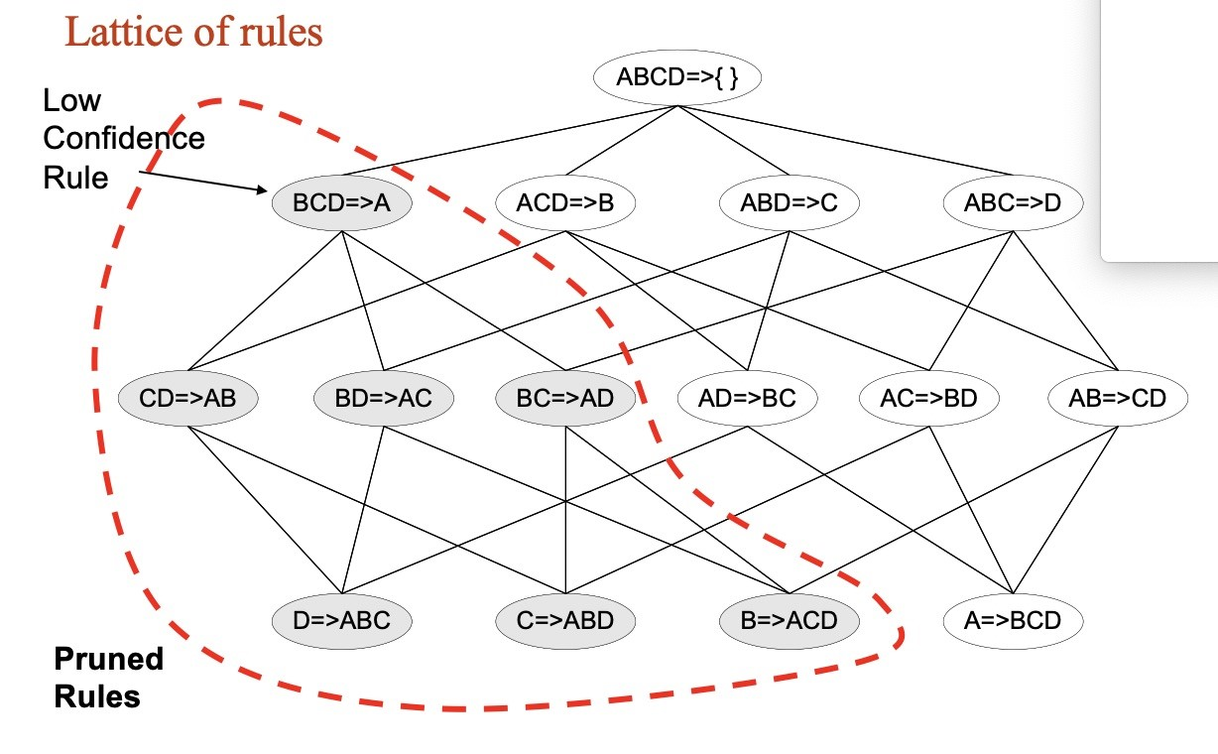

# Weather example

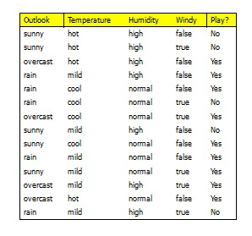

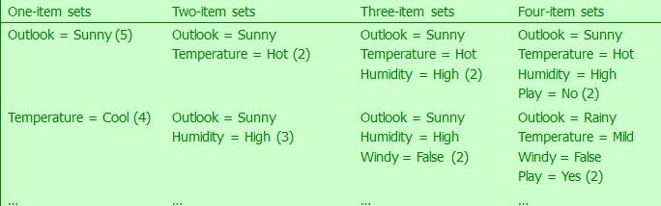

In total: (with minimum support of two)

12 one-item sets,

47 two-item sets,

39 three-item sets,

6 four-item sets 0 five-item sets

Once all item sets with minimum support have been generated, we can turn them into rules Example:

Humidity = Normal, Windy = False, Play = Yes (4)

Seven (2N-1) potential rules (6 useful ones)

If Humidity = Normal and Windy = False → Play = Yes (4/4)

If Humidity = Normal and Play = Yes → Windy = False (4/6)

If Windy = False and Play = Yes → Humidity = Normal (4/6)

If Humidity = Normal → Windy = False and Play = Yes (4/7)

If Windy = False → Humidity = Normal and Play = Yes (4/8)

If Play = Yes → Humidity = Normal and Windy = False (4/9)

?? If True → Humidity = Normal and Windy = False and Play = Yes (4/12)

# Factors Affecting Complexity of Apriori

Choice of minimum support threshold

lowering support threshold results in more frequent itemsets this may increase number of candidates and max length of frequent itemsets

Dimensionality (number of items) of the data set

more space is needed to store support count of each item if number of frequent items also increases, both computation and I/O costs may also increase

Size of database

since Apriori makes multiple passes, run time of algorithm may increase with number of transactions

Average transaction width

transaction width increases with denser data sets

This may increase max length of frequent itemsets and traversals of hash tree (number of subsets in a transaction increases with its width)

# Support Counting of Candidate Itemsets

Scan the database of transactions to determine the support of each candidate itemset Must match every candidate itemset against every transaction--- expensive operation The highlighted itemset support? Search all transactions....

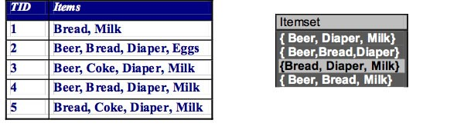

To reduce number of comparisons, store the candidate itemsets in a hash structure

Instead of matching each transaction against every candidate, match it against candidates contained in the hashed buckets

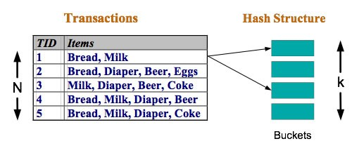

Suppose you have 15 candidate itemsets of length 3:

{1 4 5}, {1 2 4}, {4 5 7}, {1 2 5}, {4 5 8}, {1 5 9}, {1 3 6}, {2 3 4}, {5 6 7}, {3 4 5}, {3 5 6}, {3 5 7}, {6 8 9}, {3 6 7}, {3 6 8}

How many of these itemsets are supported by transaction (1,2,3,5,6)?

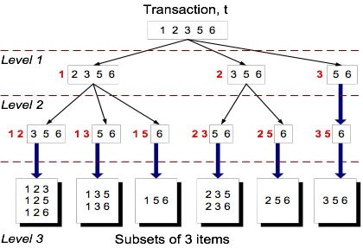

Consistent hash function. Levels of tree correspond to position of item in set

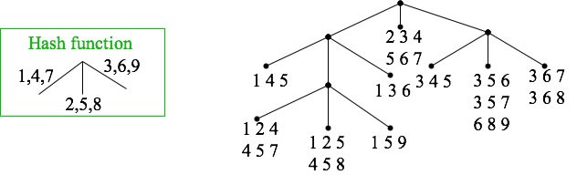

Matching transaction (1 2 3 5 6) leads to the buckets that contain the item sets to which counts can be incremented.

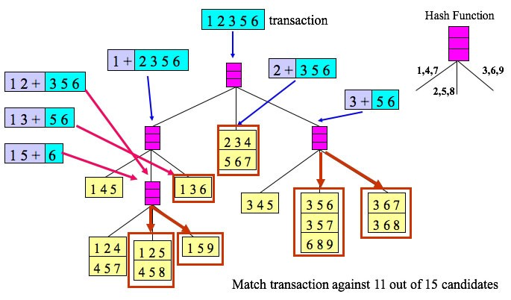

# General Considerations

Association rules do not require identification of dependent variables first. This is a good example of information discovery.

Not all rules may be useful. We may have a rule that exceeds our confidence level, but the item sets are also high in probability so not much new information is revealed. The lift is low.

If customers purchase milk, they also purchase bread (conf. level of 50%) but if 70% of all purchases involves milk and 50% of purchases include bread, the rule is of little use.

Two types of relationships of interest:

1. association rules that show a lift in product sales for a particular product where the lift in sales is the result of is association with one or more other products--may conclude that marketing may use this information
2. association rules that show a lower than expected confidence for a particular association--may conclude that the products involved in the rule are competing for the same market.

Start with high thresholds to see what rules are found; then reduce the levels as needed.